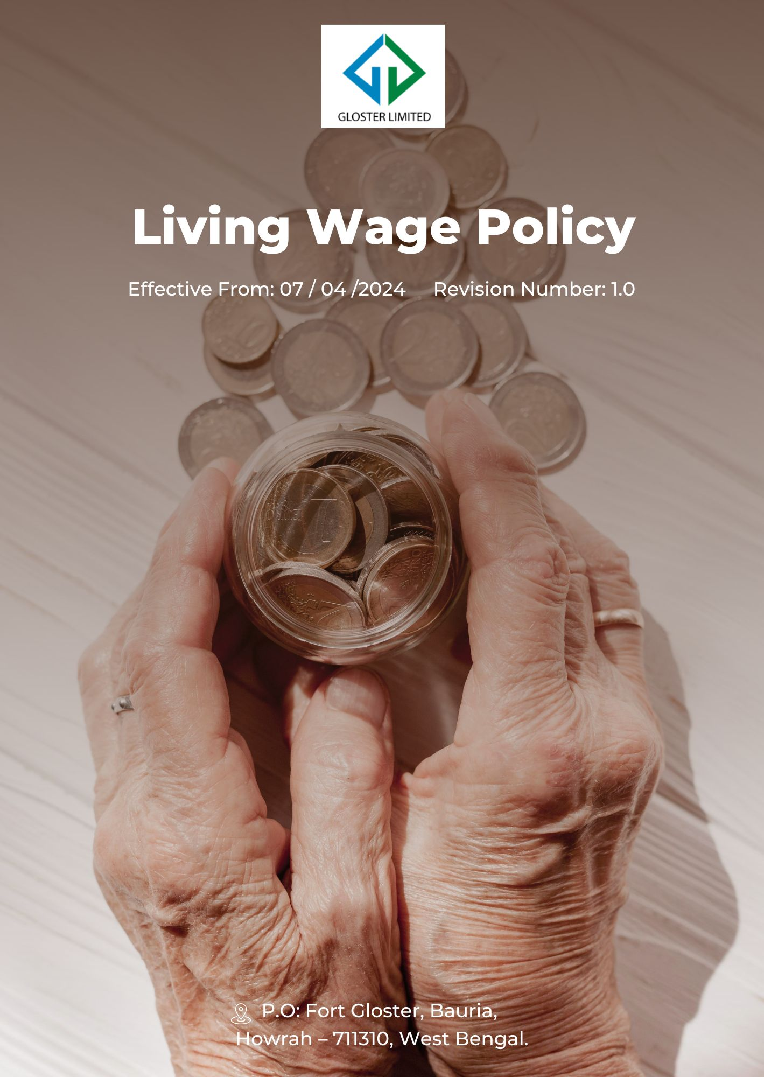
Contents
1) Preamble 3
2) Desired Outcomes 3
3) Scope 3
4) Definition: 4
5) How Living Wage should be decided 4
6) Core Strategies for Living Wage 4
7) Living wage Assessment 5
8) Accountability 6
9) Training and Education 7
10) Progress Update 8
11) Ongoing Development 9
12) Review Cycle 9
13) Employee Acknowledgement Form 10

Preamble
At Gloster Limited, we believe that a living wage is fundamental to the well-being of our employees and the sustainability of our jute manufacturing operations. This Living Wage Policy demonstrates our commitment to ensuring all workers associated with Gloster, directly or indirectly, receive compensation that allows them and their families to live with dignity. Our approach aligns with Indian labor laws, international standards, and Gloster's core values of integrity and social responsibility.

Desired Outcomes
Implementing this framework, Gloster Limited commits to providing a living wage that ensures employees can maintain a decent standard of living. Through this initiative, the company aims to achieve the following outcomes:
- Implement a living wage framework that supports a decent standard of living for all Gloster employees.
- Ensure Gloster's wages reflect the true cost of living in our operational areas.
- Foster economic stability and well-being among our workforce and local communities.
- Set a standard for fair wage practices in the jute industry and our supply chain.

Scope
This Policy applies to all employees (at all levels), stakeholders (internal and external), partners, contractors, customers, suppliers, and any other individual or entity working on behalf of Gloster Limited. It also applies to the following sites
Sr. No. | Unit Name | Address
1 | GLOSTER LIMITED – Ananya Unit | P.O: Fort Gloster, Bauria, Howrah – 711310, West Bengal
2 | GLOSTER LIMITED – Head Office | Head Office, 21, Strand Road, Kolkata 700001

Definition:
- Living Wage: Gloster Limited defines a living wage as the remuneration received for a standard work week by a worker in a particular place sufficient to afford a decent standard of living for the worker and their family. Elements of a decent standard of living include:
- Nutritious food and clean water
- Safe and adequate housing
- Education for children
- Healthcare
- Transportation
- Clothing and other essential needs
- Provision for unexpected event

How Living Wage should be decided
Gloster Limited determines the living wage through a comprehensive assessment process. This process includes conducting regular audits to evaluate the cost of living in the regions where we operate. We consider various factors such as the price of nutritious food, safe and adequate housing, education, healthcare, transportation, clothing, and other essential needs. We also factor in provisions for unexpected events to ensure a comprehensive approach. Our audits are aligned with Indian labor laws and international standards, ensuring our wage standards reflect the true cost of living. By maintaining these audits and regularly checking the standards, we ensure that our compensation framework remains fair and relevant to the economic realities of our workforce and communities.

Core Strategies for Living Wage
Living Wage Measures
- We are committed to ensuring all employees receive compensation that meets or exceeds the minimum wage by FY 2029-30, improving from the baseline set in FY 2022-23.
- To address the gender, pay gap, we have implemented the "Gender Pay Equity Review" strategy and aim to reduce the pay disparity between male and female employees by 10% by FY 2029-30 from the baseline FY 2022-23.
- We aim to narrow the wage disparity between our highest and lowest earners by 15% by FY 2029-30, with FY 2022-23 as the baseline for measuring improvements.
- To address the impact of inflation on employee wages, we have implemented the "Inflation Adjustment Strategy" and aim to increase wages by 5% to offset the inflation rate and maintain real purchasing power by FY 2029-30, based on FY 2022-23 data.

Living wage Assessment
At Gloster Limited, we prioritize fair compensation through a thorough living wage assessment. This involves:
- Regular Audits: We systematically evaluate the cost of living in our operational regions, focusing on essential needs like:
- Secure and suitable housing
- Access to education
- Healthy food
- Medical care
- Alignment with Standards: Our assessments comply with Indian labor laws and international benchmarks, ensuring that wages reflect the real costs faced by our employees.

- Continuous Review: We frequently update our wage framework to maintain fairness and relevance, guaranteeing that our employees can sustain a decent standard of living.
This comprehensive approach demonstrates our commitment to social responsibility and the well-being of our workforce.

Accountability
To ensure the effective implementation of this policy, we have established clear roles and responsibilities:
- Chief Human Resources Officer (CHRO)
- Overall Responsibility: The CHRO is responsible for the overall implementation, oversight and review of the Living Wage Policy.
- Policy Development and Review: Ensures that the policy is up-to-date and reflects the current economic conditions and standards.
- Compliance and Reporting: Guarantees that all regulatory and legal requirements are met and that regular reports are generated on the policy's impact.
- Human Resources (HR) Department
- Regular Audits: Conducts periodic audits to assess the cost of living in operational regions and ensures alignment with Indian labor laws and international standards.
- Data Collection and Analysis: Gathers and analyzes data related to wages, cost of living, and other essential needs to ensure accurate living wage calculations.
- Training and Awareness: Provides training to employees and management on the Living Wage Policy and its importance.
- Finance Department
- Budget Allocation: Ensures that sufficient budget is allocated to meet living wage requirements.
- Inflation Adjustment Strategy: Monitors economic conditions and adjusts wages to offset inflation and maintain real purchasing power.
- Gender Pay Equity Committee
- Gender Pay Equity Review: Implements and monitors strategies to reduce the gender pay gap, ensuring equitable pay for all employees.
- Reporting: Provides regular updates to the CHRO on progress towards gender pay equity targets.
- Operations Managers
- Implementation at Sites: Ensures that the Living Wage Policy is effectively implemented at all operational sites, including Gloster Limited, P.O: Fort Gloster, Bauria, Howrah – 711310, West Bengal.
- Local Compliance: Works with local HR teams to ensure that living wages are reflective of regional cost of living standards.
- Employee Representatives
- Feedback and Engagement: Collects feedback from employees regarding the Living Wage Policy and communicates any concerns or suggestions to the HR Department.
- Advocacy: Advocates for employee needs and ensures that the policy supports a decent standard of living for all workers.
- External Auditors
- Independent Audits: Conducts independent audits to verify that the Living Wage Policy is being implemented effectively and that all standards are met.
- Compliance Verification: Ensures that the policy aligns with both national and international labor standards.
- Legal Department
- Legal Compliance: Ensures that the Living Wage Policy complies with all applicable Indian labor laws and international standards.
- Policy Enforcement: Provides guidance on the enforcement of the policy and handles any legal issues that may arise.
- Chief Executive Officer (CEO)
- Strategic Oversight: Provides strategic oversight and ensures that the Living Wage Policy aligns with Gloster Limited's core values of integrity and social responsibility.
- Communication: Communicates the importance and benefits of the Living Wage Policy to stakeholders, partners, and the broader community.

Training and Education
We will provide comprehensive and ongoing training to all employees, including:
- New hire living wage orientation within the first month of employment
- Interactive online webinars on living wage adjustments and cost-of-living assessments
- Monthly updates on living wage standards and case study discussions
- Quarterly leadership workshops on living wage strategies for managers and executives
- Biannual living wage impact reviews and feedback sessions with employees
- Role-specific living wage training for employees in key operational areas
- Annual living wage refresher courses for all employees
- Online living wage resource center with guidelines, FAQs, and assessment tools

Progress Update
Gloster Limited is committed to ensuring that our Living Wage Policy achieves its intended outcomes and continually improves over time. To track progress, we have established a structured approach involving regular reviews and updates.
- Regular Monitoring: We conduct bi-annual audits to evaluate wage levels against the current cost of living, ensuring that compensation remains aligned with regional economic conditions. These audits help us identify any discrepancies and address them promptly.
- Annual Reporting: The Human Resources Department prepares comprehensive annual reports detailing progress towards achieving living wage targets. These reports include data on wage adjustments, gender pay equity, and the impact of inflation on compensation.
- Benchmark Comparisons: We compare our wage levels with industry standards and benchmarks to ensure that Gloster remains competitive and fair in its compensation practices. This also helps us set realistic and attainable goals for wage improvements.
- Stakeholder Feedback: Employee representatives collect and relay feedback from the workforce on the effectiveness of the Living Wage Policy. This feedback is reviewed and considered in our policy updates and adjustments.
- External Audits: Independent external auditors conduct annual reviews to verify compliance with our Living Wage Policy and national and international standards. Their findings are used to make necessary adjustments and improvements to the policy.
These measures ensure that Gloster Limited consistently meets its commitments and strives to enhance the well-being of our employees.

Ongoing Development
Gloster Limited is dedicated to the continuous enhancement of our Living Wage Policy through ongoing assessment and refinement. We will implement a cycle of regular evaluations to adapt our wage framework to evolving economic conditions and employee needs. By integrating feedback from stakeholders and conducting bi-annual audits, we ensure our compensation remains competitive and reflective of the true cost of living. Our approach includes benchmarking against industry standards and revising our strategy based on comprehensive annual reports. Additionally, external auditors will provide independent verification to uphold compliance and best practices. We commit to proactively addressing any discrepancies and making informed adjustments to continuously improve the effectiveness and fairness of our wage policies. This iterative process reinforces our dedication to social responsibility and the well-being of our workforce.

Review Cycle
This policy shall be reviewed annually and on an ad hoc basis by the Chief Human Resources Officer (CHRO) to ensure its effectiveness and relevance. Any significant changes will be approved by the Board of Directors.
Policy | Responsible Person | Signature | Date
Prepared by | Chief Human Resources Officer (CHRO) |  | 01st January 2024
Approved by | General Manger |  | 01st January 2024

Reviewed by | Review Date | Signature | Revised No. | Change Summary
Chief Human Resources Officer (CHRO) | 01st April 2024 |  | 1.0 | Updated section of “Progress Update”
Chief Human Resources Officer (CHRO) | 01st April 2025 |  | 1.1 | Updated “Living wage measures”
Next Review date: 01st April 2026

Employee Acknowledgement Form
I, acknowledge that I have received, read, and understood Gloster Limited's Living Wage Policy. I am aware that this policy aims to ensure fair and adequate compensation that supports a decent standard of living for all employees.
By signing this form, I confirm that I understand the key aspects of the policy, including the definition of a living wage, the process for determining wage levels, and the core strategies implemented to address wage equity and inflation. I am also aware of the responsibilities and accountability measures outlined in the policy, as well as the training and education provided to support my understanding of these guidelines.
I recognize that my compliance with this policy is essential for maintaining a fair and equitable work environment. Should I have any questions or need further clarification, I will reach out to the Human Resources Department.
Employee Name: ____________________________
Employee Signature: _________________________
Date: ______________________

